Innovation, sustainability, product development since 2002

Giuseppe Colonna
President
STC S.r.l.
23/02/2026

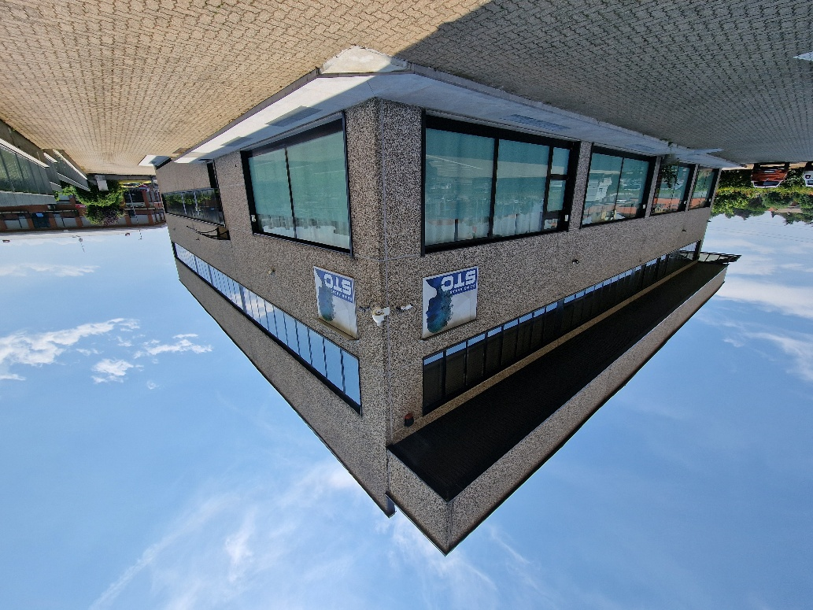
NATIONAL RECOVERY AND RESILIENCE PLAN (PNRR) – MISSION 4 COMPONENT 2 “From Research to Business” INVESTMENT 2.3:
“Strengthening and thematic and territorial expansion of technology transfer
centres for industry segments”

LCA - LCCA Project for Additive Manufacturing Systems, developed
in collaboration with CIM 4.0

CUP: B79J23001410004
- Grant: EUR 380,214.00
- Start date: 10/11/2023
- End date: 28/02/2025

INTEGRATED ENVIRONMENTAL AND ECONOMIC ASSESSMENT
LCA-LCCA AM: Optimisation, Cost Definition and Sustainability Assessment for Additive Manufacturing
Objectives, methodologies and break-even point of the project developed by STC S.r.l. to guide the ecological and economic transition in industrial components.

The LCA-LCCA project for Additive Manufacturing systems, funded by the European Union under the PNRR (NextGenerationEU), has successfully transferred an advanced analytical methodology from the conceptual to the industrial scale (from TRL 5 to TRL 7). Developed by STC S.r.l. (Alpignano, TO) in close collaboration with the CIM4.0 Competence Center, the project demonstrates how the simultaneous integration of life cycle assessment (LCA) and total cost analysis (LCCA) can redefine the competitiveness of additive manufacturing (AM) compared with traditional technologies (TM), acting as a key strategic driver for compliance with the European Green Deal.

Why focus on LCA-LCCA integration in Additive Manufacturing
In today's industrial landscape, sourcing and technology choices can no longer be based solely on initial manufacturing cost. The progressive introduction of EU regulations and emissions-related fiscal mechanisms (such as a product carbon tax) risks making high-carbon-footprint materials and processes economically and technically obsolete. Additive Manufacturing offers unprecedented geometric freedom and design flexibility. However, the production of limited batches or spare parts is often carried out on geometries originally designed for casting or high-volume moulding processes. This gap generates material waste, long print times and artificially high costs. STC's innovative response is the proprietary CO2ST® (Carbon to Cost) methodology: a software ecosystem capable of combining process economic flows (managed through proprietary databases) with greenhouse gas (GHG) emission profiles, calculated using the international ISO 14040/14044 standard on the SimaPro platform.

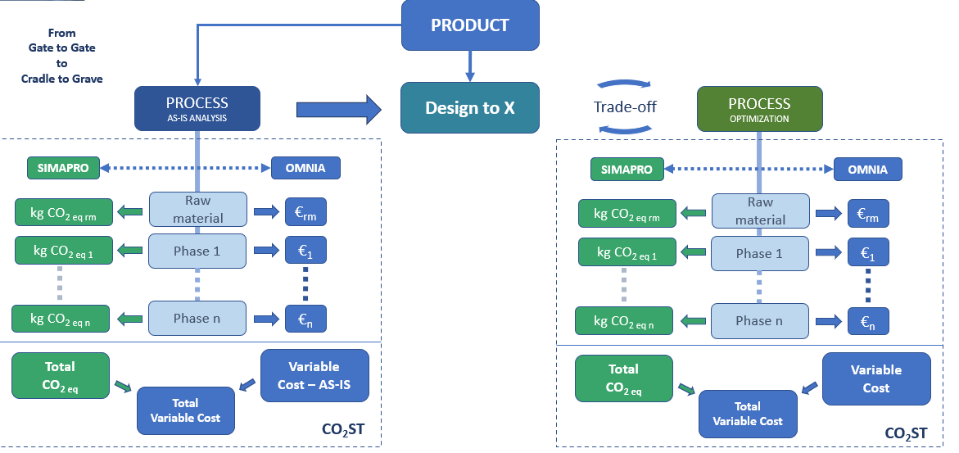
Conceptual visualisation of the integration between Cost Engineering and Environmental Assessment in STC's Design-to-X approach.

Project objectives
The action plan focused on the following methodological and experimental objectives:
- Development of the CO2ST® methodology: Permanently integrate the determination of the full product cost (Variable Cost and Tooling Cost) with the environmental impact across the entire life cycle (Cradle-to-Grave).
- Identification and analysis of 6 real case studies: Examine critical components from high-performance sectors such as automotive (Truck, LCV, Motorsport), marine and aerospace.
- AM-oriented topology optimisation: Redesign at least 3 of the target components to exploit the potential of Design to Additive Manufacturing technology (weight reduction, function integration, elimination of flanged assemblies).
- Accurate calculation of the Break-Even Point (BEP): Identify the exact production volume threshold beyond which AM technology gives way to traditional manufacturing, introducing for the first time the monetisation of CO2-equivalent impact (set at €185/tonne based on the most recent international scientific frameworks published in Nature).
- Guidelines for industry and education: Draw up technical reports and selection criteria usable both by CIM4.0 and within training programmes for future industrial designers.
The components examined and engineering evidence
The technical cooperation between STC and CIM4.0 made it possible to analyse diversified operating scenarios, mapping mechanical and economic performance. Below are three of the most significant cases from the 6 analysed:
- Oil Filter Support (Marine Application - FPT)
- As-is scenario: Bulky 15 kg component in spheroidal graphite cast iron, produced by sand casting and machining.
- AM optimisation: Material replaced with an Aluminium alloy (AlSi10Mg) on an EOS M400-4 system. Topology redesign led to an 82% weight reduction (bringing the part down to just 2.7 kg).
- Process results: Print time per cycle was reduced by 50% (16 hours), support material consumption dropped by 95% (just 65 g) and material waste was cut by 95%. The natural frequencies estimated via FEM analysis (510 Hz) remained well within the strength specifications of the base.

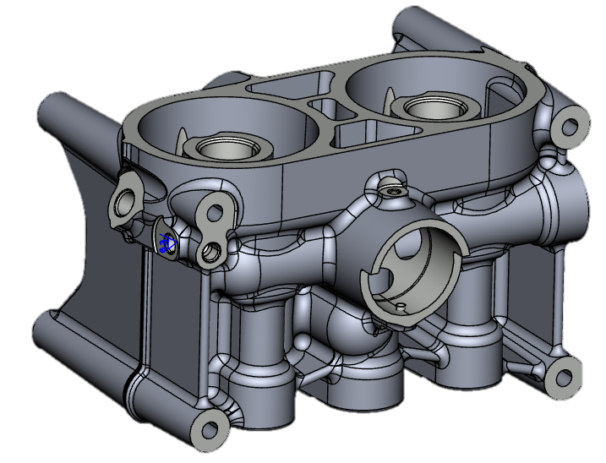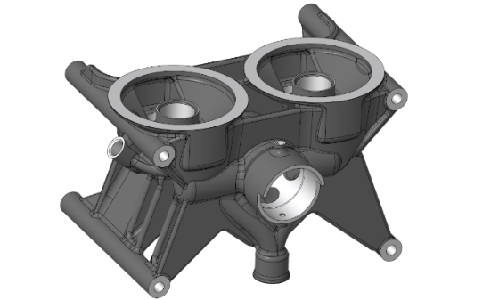
- Turbo Support Assembly (IVECO)
- As-is scenario: System made up of 3 separate sub-components (in spheroidal graphite cast iron and aluminium) joined by 6 assembly bolts, for a total weight of 5.01 kg.
- AM optimisation: Integration into a single monobloc Aluminium component free of flanged joints, with optimised geometry.
- Process results: 58% weight reduction. Part consolidation reduced the number of materials from 3 to 1 and the supply chain from 7 items to a single part number, increasing the structural safety factor by 30%.
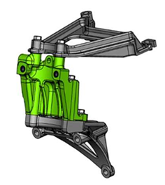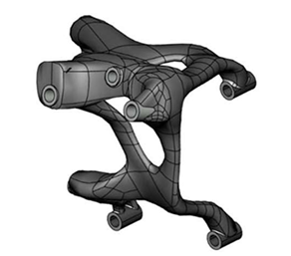

- Gearbox Shifter Stopper
- As-is scenario: Small plastic component (40 g) in glass-fibre-reinforced polyamide (PA6+GF15), produced by traditional injection moulding.
- AM optimisation: Produced in Carbon PA using Roboze OneXtreme extrusion technology.
- Process results: Geometric optimisation enabled a 50% mass reduction and a 49% reduction in operating cost, cutting support-removal time by 75% while maintaining a safety factor under load equal to 3 times the maximum expected limit.
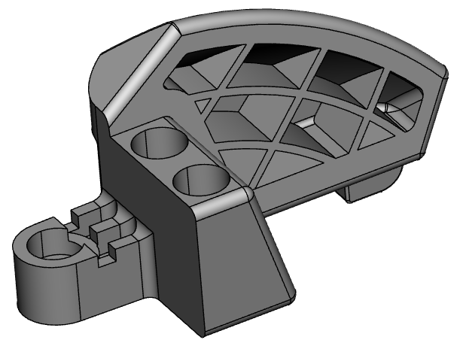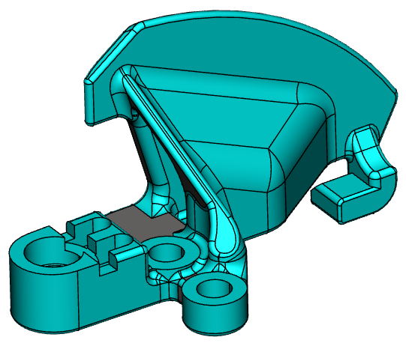

Comparative Cost Analysis and LCCA Impact
The project's real turning point lies in the quantitative measurement of economic and environmental trade-offs. The economic data show that the emissions impact of industrial tooling (moulds, patterns and machining fixtures) constitutes the most burdensome ecological cost item in traditional manufacturing.

The table below summarises the LCCA comparison for the three key components (expressed by integrating the technical production cost with the economic cost of the CO2 emitted):

Component Analysed | Technology / Scenario | Component Variable Cost (€) | Tooling Cost (€) | Total CO2 eq Impact (Tonnes)
Oil Filter Support | Traditional TM (Cast Iron) | €195 | €7,508 | 3.543 t
Oil Filter Support | Optimised AM (AlSi10Mg) | €1,163 | €963 | 0.341 t
Turbo Support | Traditional TM (Multi-material) | €214 | €28,664 | 15.594 t
Turbo Support | Optimised AM (Monobloc Aluminium) | €848 | €1,354 | 0.528 t
Gearbox Stopper | Traditional TM (Injection Moulding) | €3 | €12,453 | 5.181 t
Gearbox Stopper | Optimised AM (Carbon PA) | €13 | €114 | 0.009 t

Key results achieved
- Industrial validation of the CO2ST® framework: Demonstrated the effectiveness of simultaneously combining cost engineering and environmental assessment algorithms across a heterogeneous library of components.
- Drastic increase in the Break-Even Point (BEP): Introducing the monetised LCA cost into the financial calculation of the business case favourably shifts the Additive Manufacturing cost-effectiveness curves. For example, in the case of the Oil Filter Support, the BEP rises by 133% when the ecological penalty of traditional cast iron's industrial emissions is calculated against additive aluminium.
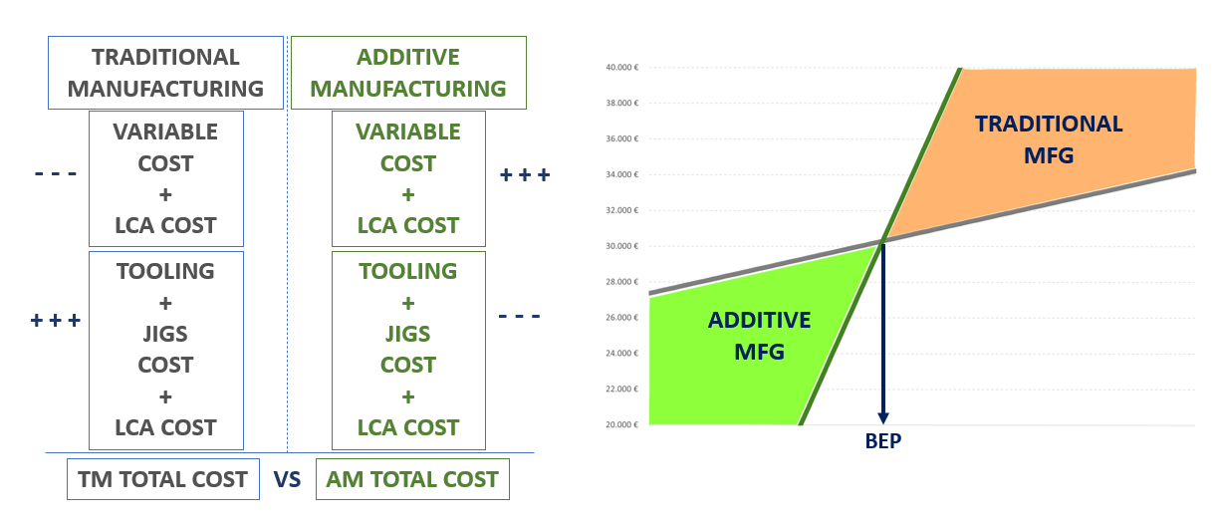

- Maximising the efficiency of limited batches: for small plastic components (e.g. the Gearbox Stopper and the Fuel Door Support), the combination of small size and geometric optimisation raised the BEP by over 1,200 units, making AM a flexible, highly profitable technology that can be modified over time without the economic and environmental burden of remaking injection moulds.
- Definition of geometric constraints and AM guidelines: Identified the fundamental geometric rules for minimising the use and removal of structural supports during part growth, such as the systematic introduction of droplet design (teardrop-shaped geometries) for internal fluid-dynamic channels and the adoption of inclinations no greater than 40° from vertical (pointed arch design) to eliminate supports in areas unreachable by machine tools.

Industrial and sustainability prospects
The project conducted by STC S.r.l. demonstrates that sustainability is not an economic constraint, but a fundamental competitive metric for businesses. The shift to Additive Manufacturing, backed by robust topology optimisation calculations, makes it possible to simultaneously cut structural weight and the carbon footprint of the production chain, eliminating intermediate logistics steps, surface treatments and complex handling. The demonstration platform developed and the consolidated numerical results provide a strategic decision-making tool for CIM4.0's industrial partners. They make it possible to plan medium- and long-term technology investments based on solid projections and objective parameters, anticipating the global scenarios of the ecological and energy transition.

