Innovation, sustainability, product development since 2002

Giuseppe Colonna
President
STC S.r.l.
23/02/2026


NATIONAL RECOVERY AND RESILIENCE PLAN (PNRR) – MISSION 4 COMPONENT 2 “From Research to Business” INVESTMENT 2.3:
“Strengthening and thematic and territorial expansion of technology transfer
centres for industry segments”

HEFFMAXGEN Project (High EFFiciency hydrogen Motor AXial GENerator)
developed in collaboration with CIM 4.0

CUP: B77H25000180004

- Grant: EUR 300,004.00
- Start date: 01/01/2025
- End date: 31/03/2026

HIGH-EFFICIENCY AXIAL HYDROGEN MOTOR-GENERATORS: THE ARCHITECTURAL REVOLUTION OF CONSTRAINED AXIAL SYSTEMS
HEFFMAXGEN Project: Optimisation, Development of the Opposed Piston Concept and
Experimental Integration on a Single-Cylinder Engine

Methodological objectives, overcoming the critical issues of traditional Free Piston systems, and validation of the first technological demonstrator developed by CNR-STEMS in collaboration with STC S.r.l. and CIM 4.0.

The HEFFMAXGEN project (High EFFiciency hydrogen Motor AXial GENerator) represents a quantum leap in the landscape of sustainable power generation systems over the medium and long term. Funded by the European Union under the PNRR (NextGenerationEU), the project aims to transfer a revolutionary engine architecture from the conceptual stage to industrial validation. Developed by the CNR Institute of Sciences and Technologies for Sustainable Energy and Mobility (CNR-STEMS), in synergy with engineering partner STC S.r.l. and the CIM 4.0 Competence Center, the project demonstrates how overcoming the kinematic constraints of traditional reciprocating engines can coexist with maximum operating stability, positioning itself as a strategic pillar for decarbonisation through zero-emission energy carriers such as hydrogen.

Why go beyond the limits of traditional "Free Piston" systems

In the context of the energy transition, free-piston generators have always attracted enormous theoretical interest. The absence of a connecting-rod/crankshaft system allows the elimination of lateral loads on the piston, drastically reducing friction losses and ensuring direct, extremely compact energy conversion.
However, the traditional free-piston architecture presents significant critical issues: the piston's motion is determined solely by the instantaneous dynamic balance between combustion forces, inertia and the electrical load of the linear generator.
This gap translates into severe combustion-control complexity and risks of motion instability, holding back mass industrialisation.
HEFFMAXGEN's engineering response is an ingenious constrained hybrid architecture: the piston is connected to a connecting-rod/crankshaft system that does not perform the energy-conversion function, but serves solely as a kinematic constraint and motion reference.
The mechanical power generated by hydrogen combustion is extracted directly by an axial linear generator interposed between the piston and the crank mechanism. This approach allows the power and control electronics to be dedicated solely to optimising electrical extraction, maximising overall efficiency without penalising weight, size or cost.

Project objectives
The joint action plan focused on well-defined methodological, modelling and construction milestones:
- Development of the high-efficiency Opposed Piston concept: Design an advanced opposed-piston architecture coupled with axial linear generators to maximise power density.
- Containing technological risk through a modular approach: Isolate the electromagnetic validation of the axial generator by first applying it to an existing four-stroke single-cylinder engine already thermo-mechanically characterised by CNR-STEMS.
- Design of advanced structural components: Develop dedicated closure discs and guide pistons capable of minimising internal pumping losses.
- Setting up the test bench and experimental validation: Integrate the kinematic chain and power electronics in a test cell to map conversion efficiency under different operating conditions.

System Architecture and Status of Activities
- The Original Concept: Opposed Piston Axial Generator
The project's long-term goal envisages a symmetrical opposed-piston structure in a two-stroke configuration. The preliminary layout, developed by the engineering partners, shows the integration of the permanent-magnet translator directly in line with the combustion chamber.
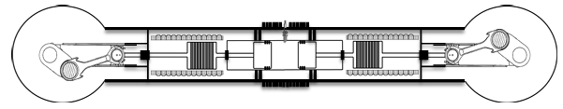

- The Single-Cylinder Demonstrator and Experimental Setup
To accelerate validation of the generator without the motion-control complications typical of pure free-piston systems, the working group successfully converted a laboratory single-cylinder engine.
The engine was installed on the test bench and carefully aligned with a reversible electric machine used for initial motoring and for the subsequent electromagnetic characterisation tests. The key components have already been procured, including the high-flux-density permanent magnets for the axial generator and the entire power-electronics chain for managing the electrical output.

Engineering Evidence and Printed Components (CIM 4.0 & STC)
Converting the powertrain required the from-scratch design and metal printing of extremely high-precision internal components to ensure perfect coaxiality between the piston axes, the translator and the stator centre, preventing abnormal wear, friction and magnetic imbalance.
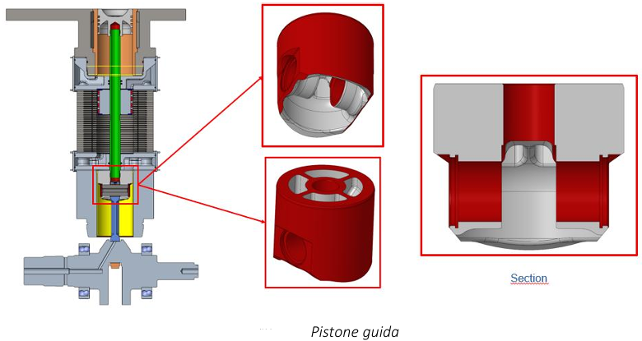
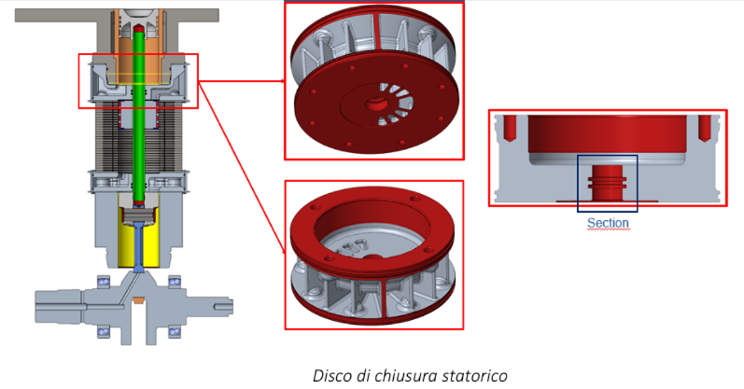
Results Achieved and Sustainability Prospects
- Validation of the Mechanical Integration Framework: Successful completion of the first phase of structural setup and test-bench alignment of the motor-generator.
- Definition of Debugging and Test Procedures: Development of a rigorous assembly sequence designed to guarantee thousandth-of-a-millimetre tolerances in the alignment of stator and translator, as a preliminary step to the electric motoring tests.
- Decision-Making Tool for the Evolution of the Concept: The data from the first experimental campaign on the single-cylinder engine will serve as a numerical benchmark to validate the simulation models. This will enable STC S.r.l. to complete the executive release of the two-stroke hydrogen Opposed Axial Piston Generator architecture within the project's closing deadlines.

The synergistic approach of the HEFFMAXGEN project demonstrates that combining traditional kinematic stability with the direct energy extraction typical of linear systems represents the key to future industrial generators. By mitigating the carbon footprint through hydrogen combustion and maximising electrical efficiency, the technology is positioned to become a pillar of excellence in distributed generation systems and for heavy-duty mobility power units.

