Innovation, sustainability, product development since 2002

Giuseppe Colonna
President
STC S.r.l.
22/09/2026
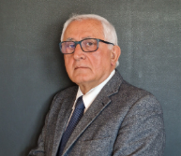

NATIONAL RECOVERY AND RESILIENCE PLAN (PNRR)
MISSION 4 COMPONENT 2 “From Research to Business” INVESTMENT 2.3 “Strengthening and thematic and territorial expansion of technology transfer
centres for industry segments”

EST LOHC Project (Energy Safe Transport LOHC)
developed in collaboration with CIM 4.0

CUP: B77H24000300004
- Grant: EUR 367,000.00
- Start date: 15/03/2024
- End date: 31/08/2025

INNOVATION FOR HYDROGEN

EST LOHC: transporting hydrogen in liquid form and releasing it where needed
Objectives, testing and results of the demonstrator developed by STC S.r.l. as part of the Energy Safe Transport with Liquid Organic Hydrogen Carrier project

The EST LOHC project took an ethanol-based cycle from laboratory scale to pre-industrial scale, demonstrating that hydrogen can be generated from a liquid organic carrier at around 80°C, with extended operation and remote control. The main result is a maximum yield of 4.28% by weight, very close to ethanol's theoretical limit of 4.34%, obtained on a demonstrator with a 4-litre reactor and an operating volume of up to 3 litres.

Why focus on LOHC
Storage and transport represent one of the main obstacles to the widespread adoption of hydrogen. The gaseous solution requires high-pressure tanks and infrastructure; liquefaction requires cryogenic temperatures; ammonia offers high transport capacity but introduces significant toxicity and handling issues. Liquid Organic Hydrogen Carriers (LOHC) address the problem by chemically binding hydrogen to an organic liquid that can be handled and stored under conditions close to ambient.

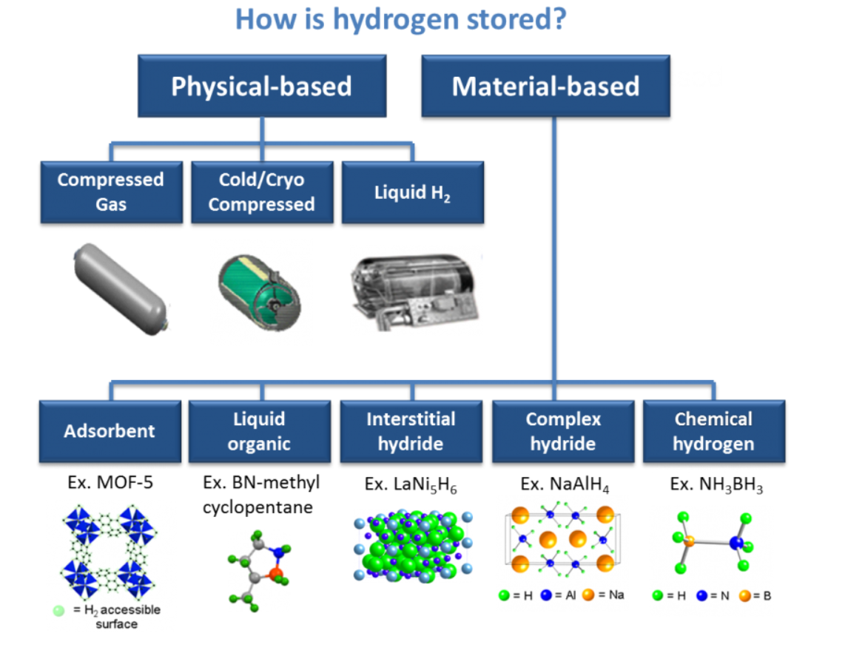

STC's vision is to develop an integrated system capable of storing the loaded carrier, separating the hydrogen at the point of use and delivering it at a controlled flow rate and pressure, while keeping the volume of gaseous hydrogen in the system to a minimum. The architecture is designed for both stationary applications and onboard vehicle use.

Project objectives

EST LOHC, promoted by STC S.r.l. under the call for innovation projects in collaboration with CIM4.0, started at an initial TRL of 5 with the goal of reaching TRL 7.
The experimental activities covered in the technical report took place between March 2024 and March 2026.

- Carry out and validate, at pre-industrial scale, the catalytic dehydrogenation of ethanol to ethyl acetate, according to the reaction 2 EtOH -> AcOEt + 2 H2.
- Verify the integrated operation of dehydration, inerting, reactor, condensation, recirculation, pressure regulation and hydrogen measurement.
- Identify the optimal operating window in terms of temperature, pressure, batch volume, catalyst loading and duration.
- Quantify the hydrogen yield relative to ethanol's theoretical maximum and compare it with the laboratory scale.
- Enable long-duration tests, from 24 to 72 hours, without continuous supervision and with remote monitoring.
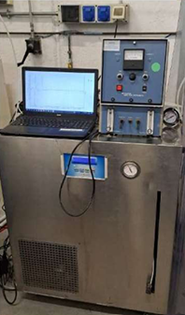
- Evaluate alternative carriers and prepare the evolution of the prototype towards industrial and mobile applications.

From the laboratory to the demonstrator
Scale-up required addressing problems that could not be foreseen from glassware trials alone. The rapid filling of the condensate collector called for a revision of the experimental plan and plant configuration. The initial campaigns therefore explored increasing volumes of ethanol, from 1 to 3 litres, under conditions ranging indicatively between 55 and 80°C and between 5 and 150 mbar of overpressure.
The 1-litre tests showed that a stable flow could not be achieved below 63°C, leading to the choice of an operating temperature of no less than 75°C. The coordinated analysis of temperature, pressure and flow clarified the effect of thermal cycles, the return of cold condensates and the openings of the discharge circuit.

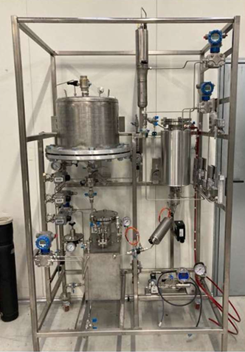

Automation and extended testing
One of the decisive steps was replacing manual condensate discharge with a timed pneumatic valve controlled by a float. Automatic opening on reaching around 350 mL, with a residual of about 100 mL, removed the need for continuous supervision and made possible 24-72 hour campaigns controlled remotely via VPN.
In the 2-litre test, lasting 25 hours at 80°C and 150 mbar, the system operated without operator intervention. 272,640 mL of hydrogen were produced, equal to 24.54 g and a yield of 1.55% by weight relative to the ethanol charged. The subsequent 3-litre tests made it possible to assess the effect of catalyst loading and refine thermal management, raising the chiller setpoint from 4 to 12°C to reduce the thermal swings caused by condensate recirculation.

Key results achieved
- Demonstrated hydrogen production at pre-industrial scale via catalytic dehydrogenation of ethanol using a Ru-MACHO catalyst and NaOEt co-catalyst.
- Achieved a maximum yield of 4.28% by weight of H2, equal to 98.6% of ethanol's theoretical limit, set at 4.34%.
- Defined a reference operating window around 80°C and 150 mbar, with volumes up to 3 litres and experimental campaigns lasting up to 70 hours.
- Developed a measurement method based on integrating the hydrogen flow, corrected for interruptions due to valve openings, and qualitatively verified the nature of the gas produced.
- Made the demonstrator operable without continuous supervision thanks to automatic condensate discharge and remote monitoring.
- Identified sodium acetate and sodium chloride among the solid residues, clarifying their origin in trace water and defining guidelines to limit their formation.
- Confirmed, on an exploratory basis, the dehydrogenation of methanol and mapped out possible alternative carriers, including 1,4-butanediol, isopropanol, dibenzyltoluene and methyl formate.

A result close to the theoretical limit

The comparison with the laboratory scale shows that the demonstrator requires longer times to achieve similar yields, but confirms the transferability of the process. The maximum value measured, 4.28 wt%, is particularly significant because it places the system within a few hundredths of a percentage point of ethanol's theoretical maximum. Ethanol thus emerges as a readily available carrier that is relatively low in toxicity and can be dehydrogenated at moderate temperature.

The related patent portfolio
The EST LOHC demonstrator provides experimental validation of the dehydrogenation stage underlying several of STC's patented solutions. The general concept involves generating gaseous hydrogen from the liquid carrier only when required, stabilising its pressure and avoiding, as far as possible, large volumes of compressed gas on board or in the plant.
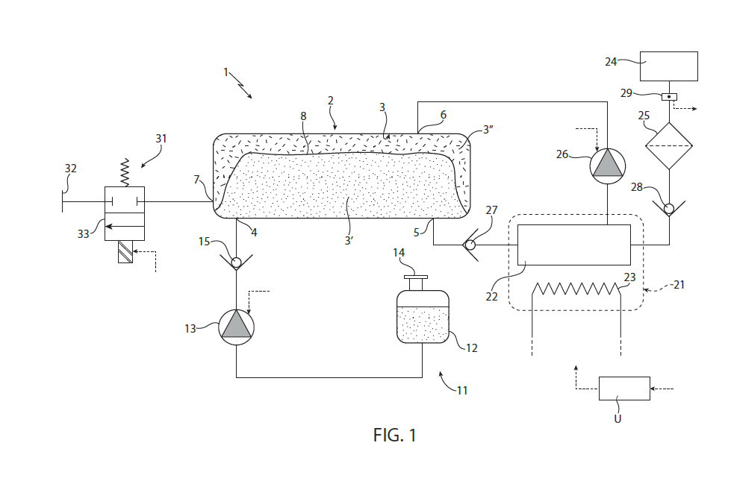
Patent diagram of the LOHC system showing separation between the loaded and discharged carrier and hydrogen generation.
Source: STC LOHC + patents presentation.

Application / publication | Title and essential content
102022000010202 / IT202200010202A1 (STC 006) | Feed system for a hydrogen engine. Filed 17/05/2022; pressure regulation via a liquid pumping circuit.
102022000025239 / IT202200025239A1 (STC 014) | Feed system for a hydrogen vehicle and related control method. Filed 07/12/2022; tank separated by a membrane for the loaded and discharged carrier, connected to a gasifier.
102023000018669 / IT202300018669A1 (STC 016) | Feed system for a hydrogen vehicle. Filed 12/09/2023; evolution featuring a catalytic membrane through which the liquid carrier passes to generate gaseous hydrogen.
102023000023682 / IT202300023682A1 | STC application filed in 2023. The technical report does not state the title, full date, classification or inventors; this data requires verification against the official file.

Industrial prospects
The experimental phase has transformed the project from a system concept into a demonstration platform capable of producing, measuring and regulating hydrogen over extended periods. Key priorities remain the optimisation of catalytic membranes, reducing reaction times, humidity control, improving the reliability of regulation components, and selecting the carrier best suited to each application.
The industrial interest of LOHC lies chiefly in the possibility of integrating storage, transport and on-demand generation within a single architecture. For vehicles, fuel cells, internal combustion engines and stationary applications, the path charted by EST LOHC aims to reduce infrastructural complexity and the risks associated with handling large quantities of compressed or cryogenic hydrogen.

In summary
EST LOHC has demonstrated that the ethanol-ethyl acetate cycle can be transferred to a pre-industrial demonstrator, achieving a hydrogen yield close to the theoretical limit and long-duration automated operation. The results obtained strengthen the technical foundation of STC's patented solutions and point to a concrete trajectory towards modular LOHC systems for mobility and for point-of-use hydrogen production.
Editorial note: data, images and patent references are drawn exclusively from the attached STC materials. For external publication, the legal status and bibliographic data of the patents must be verified against the official registers.

